TheDigitalCardBox User Journey and Economics
Guest and host walkthrough with illustrative revenue and cost at each step
13 October 2026 | United States MVP planning scenario
Decision summary. The first pilot uses one or more host supplied external destinations per event, with one confirmed destination per enabled service. A guest picks a host-enabled service and sees its exact payee, checks the recipient again inside the payment app and sends money directly to the host. Our app never treats a link open as a paid gift; the host checks their account and may mark receipt. Notes and basic cards are free, and premium cards and $15/$30/$79 books are later optional sales. The gift principal belongs to the host and is never platform revenue.

October 2026 delivery alignment
TheDigitalCardBox is the working name. The October private MVP lets hosts share a link or QR, guests leave cards or notes and choose a host-confirmed external gift service, and hosts revisit a private CardVault. Manual and editable AI-assisted choices are in the October slice. Gift transfers remain unverified by this app. Premium event-book sales, generated art and licensed song clips are later gates; the example economics below are planning scenarios, not October sales.

Assumptions and interpretation
Item | Planning assumption | Meaning
Gift and fee | $100 gift; 3% guest fee only in approved integrated route. | Guest pays $103, host receives $100; $3 is gross platform fee revenue.
Processing | 3.2% of entire $103 charge = $3.296, rounded to $3.30. | Illustrative planning rate; not a provider quote or guaranteed approval.
Premium book | Optional $15 / $30 / $79 polished book based on 0–99 / 100–299 / 300+ included entries. | Purchased once after day 90; entry count is not guest capacity and never blocks a guest.
AI text | 1,500 input and 450 output tokens = about $0.000375 per request. | Planning calculation; verify actual model and billable usage.
AI artwork | $0.06 per generated medium square image reserved; two images = $0.12. | OpenAI GPT Image 2 lists $0.053 output per medium 1024×1024 image; allowance includes small input buffer; meter actual usage. [5]
Photo and export | $0.01 per stored photo and $0.05 per export reserved. | Planning allowances for variable operations; actual storage, retrieval and email may differ.
Infrastructure | $57–$77/month line-item software case at low volume. | Shared monthly software baseline, not a per-event charge.

A positive amount in business revenue is a charge to the platform; gift principal is never its revenue. In the external pilot the host enters and confirms each enabled service’s payee identifier, and the guest chooses one and reviews it before leaving, and the payment service handles the transfer. A guest report and link open stay unconfirmed; the host may manually mark received after checking their account. This cannot guarantee that the host entered the right account or eliminate liability for the app’s own errors. The example excludes taxes, refunds, support, payout charges, disputes and partner minimums.

Walkthrough from invitation to event book
Stage and user view | What happens and who holds money | Business revenue | Modeled cost
1 Host creates event | Host signs in, sets a dated event and time zone. Contributions can open up to six months before that date and continue for 90 days after; an undated one-off page must set a close date within 90 days of publishing. | $0 | $0 marginal; monthly base below.
2 Host enables gifts | External: host enables one or more services, entering and confirming the identifier for each, checks it in that service and confirms; publishing and changes require protected host access. Integrated onboarding is later. | $0 | Provider verification fees unknown.
3 Host shares link or prints QR | Guests open one URL by link or QR. The server shows note/card/gift actions only within their allowed windows; a closed URL shows a closure page. | $0 | Page traffic in monthly base.
4 Guest writes note | Guest can type directly or request three AI drafts, choose and edit one. | $0 | About $0.000375 per example text request.
5 Guest designs card | Guest chooses static or AI artwork, optionally adds a licensed catalog clip, then approves text and visibility. No-song path stays available. | $0 | Two AI images = $0.12; optional photo = $0.01. Music fee is unquoted and excluded.
6 Guest sends external gift | Guest chooses among host-enabled services and reviews the selected host name, service and full identifier on our page, then checks the payee shown by the payment app before sending $100 directly. Host checks their account; our status is unconfirmed until host marks received. | $0 transaction fee | No platform processing charge; wallet fees are outside model.
7 Guest uses integrated route | If approved, guest reviews $100 gift + $3 fee and pays $103 on provider page. Signed webhook confirms status. | +$3.00 fee | −$3.296 modeled processing; net −$0.296 before other costs.
8 Host views event book | After day 90 the host previews the consented book and may purchase a polished copy at the tier for entries actually included. A basic private CardVault/export remains. | +$15 / +$30 / +$79 if purchased | −$0.785 / −$1.22 / −$2.641 modeled purchase and export cost.
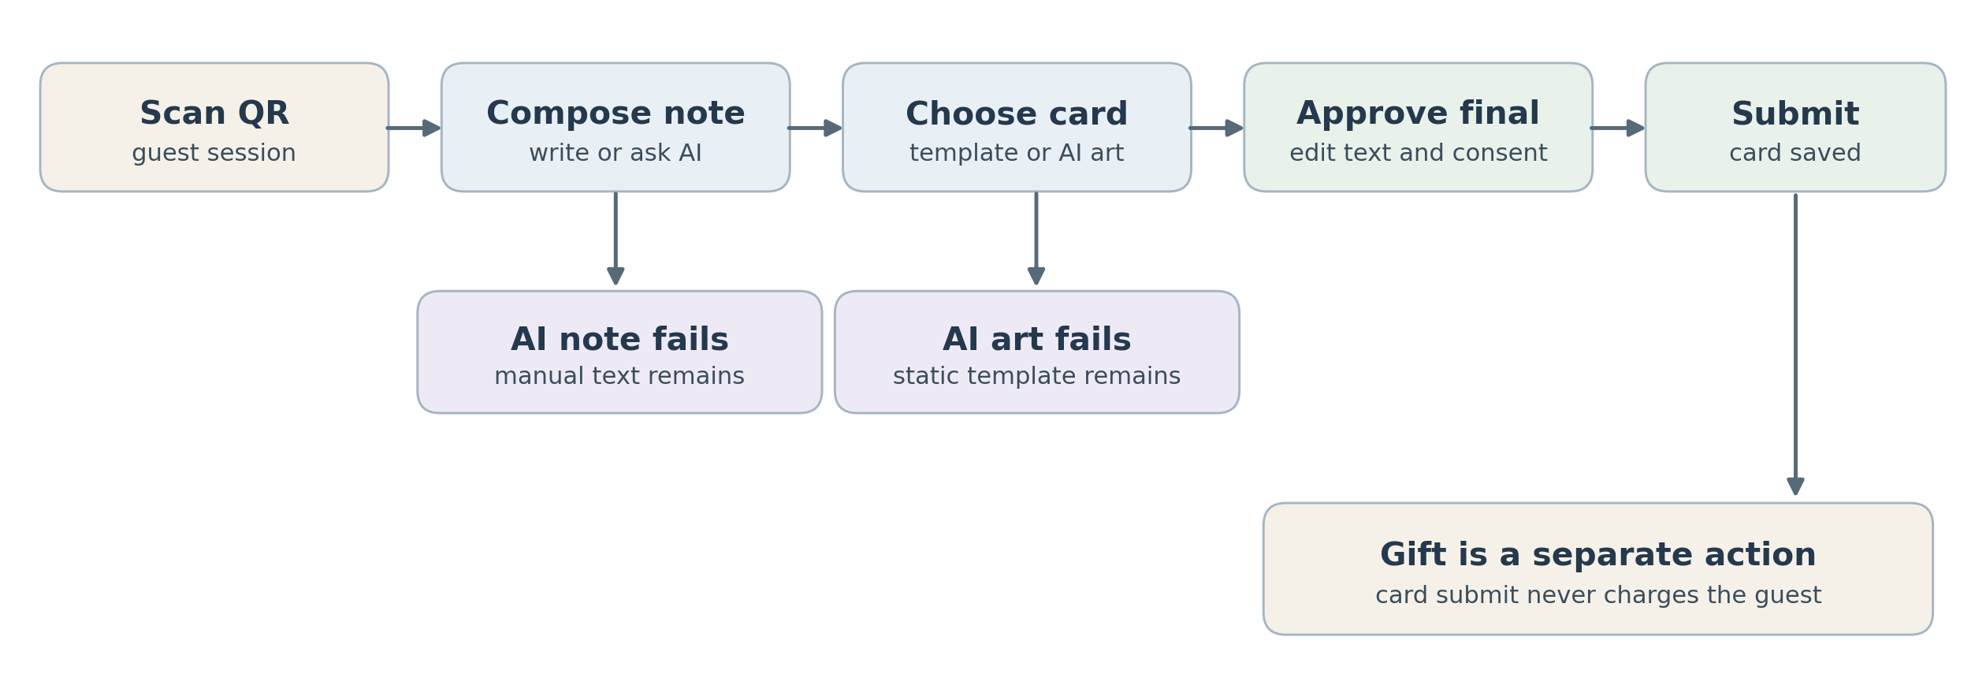
Guest path A note and card can be finished without a cash gift

What the screens say
Screen | Guest or host message | Financial consequence
Host setup | “Enable Cash App, Venmo, Zelle or a combination; enter each exact destination twice. Check it in that service, then confirm it is yours. Guests will see these details.” | No fee unless host separately buys premium.
Note and card | “Choose a draft, design your card, and optionally add a licensed song. Review before sending.” | AI and art costs are platform costs; music cost applies only with a signed license and guest selection.
External gift | “Choose a service. Send directly to [host supplied full identifier] in [selected service]. Check that the recipient shown there is the person you intend. If it differs, stop and contact the host. We do not process or verify this gift.” | No platform fee in this model; no false paid confirmation.
Integrated checkout | “Gift $100; service fee $3; total $103.” | Only when fee structure and funds flow are approved.
Confirmation | “Your card was submitted. The gift is not verified by this site. The host can mark it received after checking their payment app.” | Social content and money states stay separate.
Host dashboard | “External: link opened, guest reported, or host marked received.” Do not imply a provider verified transfer. | Totals exclude unverified external handoffs.
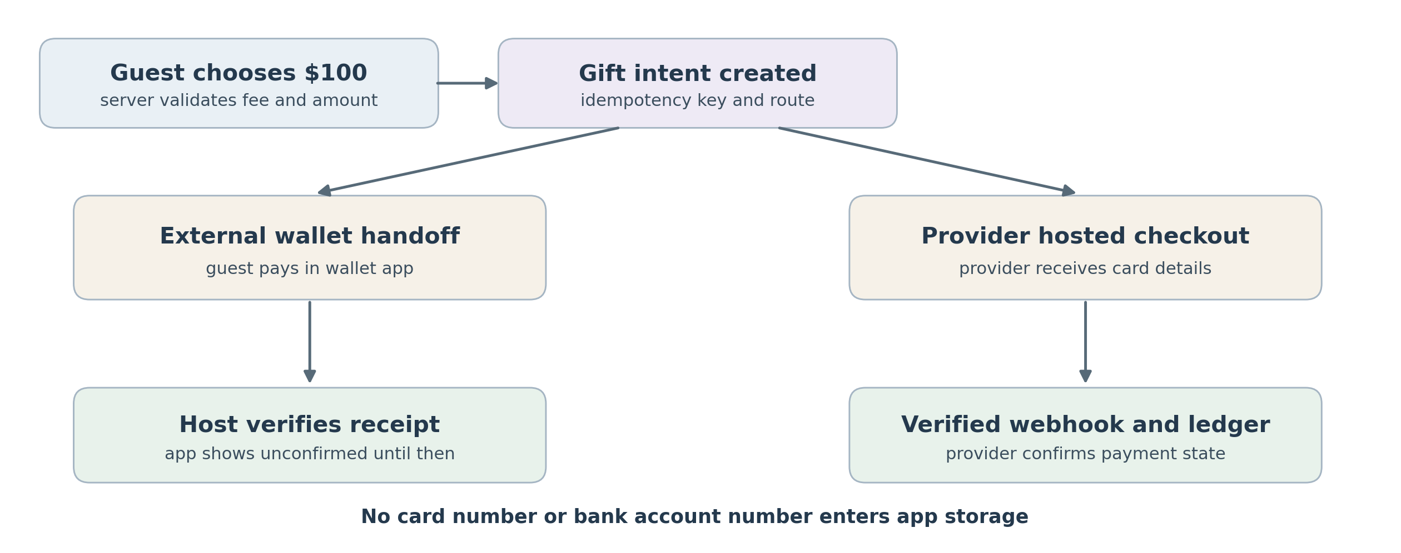
Gift path Only the provider can confirm an integrated payment

One event example with one hundred gifts
Assume one dated wedding has 100 gifts of $100 and 100 consented entries included in its premium book, 40 AI note requests, 10 guests requesting two artwork options each, 20 photos, one export and one $30 book purchase. Book checkout occurs only after day 90; the separate wedding gift-only route can remain through month 12. Every illustrative integrated gift uses a card. This is a sensitivity scenario, not a forecast of attendance or conversion.
Line item | External wallet pilot | Approved integrated route
Gift principal to host | $10,000 sent in external apps | $10,000 routed by provider; not platform revenue
Premium event revenue | +$30.00 | +$30.00
Guest fee revenue | $0.00 | +$300.00 (100 × $3)
Modeled processing including book | −$1.17 ($30 book payment at 2.9% + $0.30) | −$330.77 ($329.60 gift processing + $1.17 book payment)
AI text, image, photo and export allowances | −$1.47 (rounded) | −$1.47 (rounded)
Contribution before monthly base | +$27.37 (rounded) | −$2.24 (rounded)
After $57–$77 monthly software | −$49.64 to −$29.64 | −$79.24 to −$59.24

Unrounded variable allowance: 40 × $0.000375 + 20 × $0.06 + 20 × $0.01 + $0.05 = $1.465. A $30 premium purchase incurs $30 × 2.9% + $0.30 = $1.17. External contribution: $30 − $1.465 − $1.17 = $27.365. Integrated contribution: $30 + $300 − $329.60 − $1.465 − $1.17 = −$2.235. The last line subtracts only the $57–$77 monthly software baseline. With no book purchase, remove its $30 revenue, $1.17 card fee and $0.05 export allowance. Book price is based on included entries, not gifts. [5]

What could change the economics
- Provider approval and fee design: the 3% guest fee is illustrative and may not be available for the proposed event gifting flow. Confirm merchant of record, custody, payer fee presentation, underwriting, refund and payout terms in writing. [2][3]
- Monthly provider minimums: Moov describes a $500 monthly transaction minimum on a standard plan. Whether it applies, how eligible fees count toward it and how any shortfall is billed depend on the chosen agreement. Do not add $500 again to processing without the contract. [3]
- Refund and dispute exposure: a reversed gift can remove the fee and create extra cost. Support time, fraud loss, payout and bank verification charges are omitted from the example and can exceed the thin contribution shown.
- Premium conversion: test the $15/$30/$79 included-entry tiers after day 90; a host can preview for free and still use the private CardVault and basic export without buying a polished book. [1]
- AI usage: text is cheap under the token assumption, while image charges vary with model and quality. Meter both, limit variations and replace the $0.06 image allowance with measured charges. [1][4]

Source notes and next pricing decision
The example uses a $100 gift, 3% fee only for an approved integrated route, 3.2% illustrative processing cost, and a $30 premium book with 100 included entries. It adds explicit allowances for art, photos and export. Before launch, replace planning allowances with provider contract prices, actual AI bills and measured operations. Other book sizes produce different contribution.
[1] Planning baseline coordinated with TheDigitalCardBox MVP Timeline, System Design and Flowcharts, Executive Summary, and Financial Summary, 13 October 2026.
[2] Stripe hosted checkout workflow — https://docs.stripe.com/payments/checkout/how-checkout-works
[3] Moov hosted onboarding and plan minimum — https://docs.moov.io/guides/accounts/hosted-onboarding/
[5] OpenAI image generation cost examples — https://developers.openai.com/api/docs/guides/image-generation ; Stripe domestic-card pricing — https://stripe.com/pricing
[4] OpenAI API token pricing — https://developers.openai.com/api/docs/models/gpt-6-luna

Artwork sourcing and optional song economics
The one-event example includes AI image allowances but assumes no outsourced designs and no music selections. Its modeled contribution is +$27.37 for the external-wallet case and −$2.24 for the approved integrated case before the $57–$77 shared monthly base. Gifts belong to the host; songs do not change payment status or the illustrative fee. The premium book sale is a post-pilot sensitivity, after day 90.
Service or option | Public cost / quote status | Model treatment
Commissioned illustrations | 99designs estimates US$299–US$1,499 per brief; illustration contest starts at US$349. | Four briefs imply US$1,196–US$5,996 one-time if each costs the listed range. Spread actual spend over events using the designs; verify rights and revisions.
Adobe Stock plan | US$29.99/month for 10 standard assets with annual commitment, paid monthly. | Potential sourcing expense. Standard license may not cover assets used as the primary value of a reusable card template; extended/enterprise license cost is unquoted.
Licensed popular song clips | Feed Clips describes a pre-cleared API catalog; card-specific commercial rate is quote required. | Track setup fee, monthly minimum, clip/stream usage and territory/retention terms separately; do not assume $0 or use platform previews as a license.
Original commissioned music | Composer/producer quote required for both composition and master rights. | Alternative if scope is too narrow or expensive; specify web playback, sharing, event book, term and export rights in the agreement.

Worked sensitivity, without inventing a music price: amortizing four commissioned illustrations over 100 events adds $11.96–$59.96 per event before revisions and taxes. External contribution becomes +$15.41 to −$32.60 before monthly software; integrated contribution becomes −$14.20 to −$62.20. Let M be a quoted monthly music minimum, E active events sharing it, U selected clips or billable plays per event and p the contracted unit rate. Incremental music cost per event is M/E + U × p, plus allocated setup fees. Subtract any applicable stock subscription allocation too. Do not add a minimum on top of usage unless the contract requires both.
Guest journey: the optional picker follows artwork selection. “No song” is the default. A guest previews licensed clips after tapping Play, selects one for the card or note, and can remove it before submission. A recipient sees a Play control only if the rights check passes at view time. If rights expire, show the card and song title without audio; exports contain no sound unless export rights are explicitly granted. Test song attach rate, extra completion time, premium conversion and contribution after actual royalty charges.
Price and rights sources checked 28 September 2026: https://99designs.com/pricing/illustrations ; https://stock.adobe.com/Plans ; https://stock.adobe.com/license-terms ; https://www.feed.fm/clips ; https://www.copyright.gov/engage/musicians/ . Public prices are benchmarks, not contract offers for this use case.

Shareable occasion path
A recipient can use a dated event page for a gathering or an undated one-off page for a birthday or milestone with a chosen close date within 90 days of publication. The same opaque URL works as a direct link or QR. For dated events, host-selected contribution opening cannot precede six calendar months before the date; notes/cards/photos close at day 90 after it. Weddings alone keep gifts open without new book entries until month 12. After the applicable deadline the QR and link show a closed page with no new cards or gifts. The host retains private CardVault access and basic export. Optional premium cards, books priced by included note or card submissions after close, and an approved integrated gift fee are platform revenue.
The copied event link never exposes the host dashboard or bank details. The public gift page lists only confirmed enabled services and shows the full host approved payee identifier for the guest-selected service; Zelle email or phone is visible to givers and should be a dedicated address or number if privacy matters. The guest must compare the payment app recipient with the intended host. Changing one destination pauses only that service until fresh host authentication, review and a change alert; other confirmed services remain available. A guest switch resets their payee acknowledgment. Store the selected service and exact destination ID/version displayed with the gift intent. Host and guest may still make mistakes, and legal copy cannot waive responsibility for an app defect. Counsel should approve the final terms. The 100-gift economics remain illustrative; one-off pages may have fewer givers.

UI presentation update – 13 October 2026
The sample UI now follows the founder-supplied Margot reference (https://demo.17thavenuedesigns.com/margot/): blush backgrounds, white editorial panels, the supplied company logo centered in the header, three photographic entry points, and an introductory sidebar. The shared palette is #F9F3F2, #EADCD9, #DFCAC4, #CAA79E and #222222. Forum headings, Montserrat labels and Hanken Grotesk body text use locally hosted open-license fonts. The reference script font, Miss Noteworthy, requires a licensed webfont; La Belle Aurore is the temporary fallback.
Home, Guest, Host, About and Contact use direct page URLs. The complete clickable concept keeps its guest and host flows with the same visual theme. Notes and gifts remain independent; demo destinations are visibly sample-only, service switching resets recipient acknowledgment, and no handoff proves payment. This presentation update does not decide the production server stack or replace the MVP release gates.
The Contact page lists Support Email: support@digitalcardbox.com and General Info: info@digitalcardbox.com as email links. Its validated form prepares a local copyable draft: support and guest-experience topics go to Support, while general questions, hosting and feedback go to General Info. Visitors can open the draft in their own email app to review and send it. Preparing a draft does not deliver or persist a message. Canonical presentation details are in docs/specs/UI_DESIGN.md; product, security and event-window decisions remain in their existing specifications.

Additional host event choices – 13 October 2026
The host setup dropdown retains Wedding, Other dated event and One-off occasion. Added choices are Gender reveal parties; Sip and sees; First Communions / Confirmations; Debutante balls / Cotillions; Proms (and pre-prom parties); College Decision Day; Bridal showers; Bachelor and bachelorette parties; Rehearsal dinners; Housewarming parties; Retirement parties; Career promotions / Professional graduations; Bat Mitzvahs; and Wakes / Celebrations of Life.
Each added choice uses the existing dated non-wedding lifecycle, with notes, cards, photos and gifts closing at day 90. Only Wedding can retain gifts through month 12; wedding-related parties do not inherit that extension. One-off occasion remains bounded by a chosen close date within 90 days of publication. Selected event labels appear in the sample setup summary and guest landing; wakes and celebrations of life use remembrance wording. The demo still provides no production event validation or payment verification. Canonical choices are recorded in docs/specs/PRODUCT.md.

Customer-facing About overview – 13 October 2026
Celebrate simply. Keep what matters. TheDigitalCardBox is being built to bring the warmth of traditional greeting cards into a simpler, mobile-friendly celebration experience. The broader vision connects elegant digital invitations, personal e-cards and optional cash gifting. Hosts share an event link or QR, guests leave meaningful messages from wherever they are, and a planned private CardVault keeps kind words and consented memories together after the occasion.
The About page emphasizes fewer last-minute card runs, ATM stops and envelopes to manage, with more time for the people who matter. Gifts remain optional and use host-enabled external services. The customer introduction describes a preview and broader vision, not a release claim: it makes no promise of permanent archiving, guaranteed security, integrated transfers or an available native mobile app. October release scope and acceptance gates are unchanged.

Company logo placement – 13 October 2026
The founder-supplied IMG_8033.heic logo is displayed in the shared header and a smaller footer on Home, Guest, Host, About, Contact and the full clickable demo. Both placements link home and include meaningful alternative text. The original envelope-and-box artwork, Digital Card Box lettering and Elevating events & memories tagline are retained in a lossless PNG conversion. A CSS viewport hides the outer screenshot framing without changing the bitmap. A simplified envelope-and-box symbol serves as the browser-tab icon.
The company logo replaces the provisional script text wordmark. The supplied Margot-inspired colors and page typography remain; decorative script accents keep their existing fallback. Avoid additional company marks in guest cards, personal messages, forms and book entries, so the experience stays focused on each host and celebration. Placement and asset details are recorded in docs/specs/UI_DESIGN.md.

Database design and delivery update — 13 October 2026
Canonical decisions: docs/specs/DATA_MODEL.md and ADR 0005. Use one managed PostgreSQL database per environment with private object storage for photos and exports. Evaluate Supabase first; actual provider, version, identity integration and connection adapter remain subject to the ADR 0001 deployment spike. No database/service is provisioned by this planning change.
Store one provider-linked customer identity, anonymous event-scoped guests separate from expiring sessions, unified note/card submissions, explicit consent and moderation history, immutable encrypted gift destination versions, external intent/activity and private book snapshots/exports. Module boundaries remain public contracts with scoped relational keys and short shared transactions. Outbox and deduplication protect accepted writes and host alerts.
External gift activity is unconfirmed unless the host marks a checked receipt; neither a handoff nor a guest report proves payment. Future premium purchase transactions belong to Billing orders/attempts/verified events/entitlements/refunds. Approved integrated gift processing has a separate Gifts ledger/payout/reconciliation design and requires a new provider-approved ADR.
The detailed backlog now has 180 October hours across 54 stories: previous 156 hours plus 24 explicit database-foundation hours in DCB-E18. Weekly totals are 72/54/54, so October 31 requires capacity replanning. The prior 114–157 October and 126–192 broader-pilot ranges are historical; the provisional broader pilot is 192–215 hours (180 + prior 12–35 follow-on allowance), pending overlap review. Do not add the old aggregate database allowance again. The fixed one-time $500 development arrangement and vendor-price assumptions are unchanged.
Existing feature stories own behavior; existing Security stories own encryption and tested database/media restore, published retention and a manual deletion runbook. Database design alone is not implementation or verified transaction history. Guest intake closure does not delete private CardVault records or promise indefinite hosting. Automated deletion and future checkout remain Post-MVP.

